

Perera et el

**2013**

**Culinarydelight.info**

**Development Documentation**

**Online Restaurant-Order Management System**

**T.Perera 300668009**

**Wickrama Jayasinghe 300666580**

**Jeevanprakash Mendonca 300651451**

**Hui Feng Zhou 300491545**

**Kawser Fatema 300654304**

**05 December 2013**

Table of Contents

Project Overview 3

Context Flow Diagram 4

Deliverables 5

System Class Domain Diagram 6

Project scope 6

Administrator Manages Online Menu 7

Customer Can Manage his/her Account 8

Customer Can Order Food 12

Administrator Manage Order 15

Customer Make Payment Online 16

Management Structure 17

Project Lifecycle 17

Project Organization 17

Internal Structure 18

Roles and Responsibility 18

Staffing 19

Risk Management 19

Top Risks List 19

Risk Mitigation Strategy: 19

Planning and Control 19

Estimation Method 19

Resource Identification 20

Staff 20

Time 20

Cost 20

Tracking and control 20

Milestones 20

Major Milestones 20

Minor Milestones 20

Reporting 21

Weekly Report 21

Sprint Report 21

Estimation Refinements 21

Technical Process 22

Methods, Tools and Techniques 22

Scrum Methodology: 22

Revision Control: 22

Daily Builds: 22

Technology 22

Environment 22

Methods, Tools and Techniques 22

Hardware requirements; 23

Minimum Hardware requirements for Online Restaurant-Ordering System web hosting: 23

Hardware minimum requirements for installing web server and SQL server 23

Project Artifacts 24

# Project Overview

Online Order Management System is designed for the client, culinarydelight.info, which currently has an online restaurant, at No.44, Root Crescent, Ajax ON L1T4M3. At present the web page allows users to see the menu options, Contact page and feed back page that would notify the owner by an e-mail only. The page does not have any search optimization. Further, the system does not support management of the business and report generation.

The product will be a web-based application. The product is currently developed for windows operating system users, and in the future to be expanded for other OS systems. Multi-level access is required in order to properly accommodate both administrative as well as client user functionality.

The Scrum methodology will be used by the development team to deliver this application. This project is expected to be completed in 16 weeks from starting date of September 3rd 2013.There will be a scrum master, product owner, developers who would also assume the roles of QA and UI designing. End users would be expected to participate in the development of the project right from the beginning till the deployment of the new system.

## Context Flow Diagram



Context Flow Diagram

# Deliverables

Detailed list of features will be created after requirements gathering.

The figure below outlines the high-level releases for the Online Order System:

**System Use Case Diagram;**

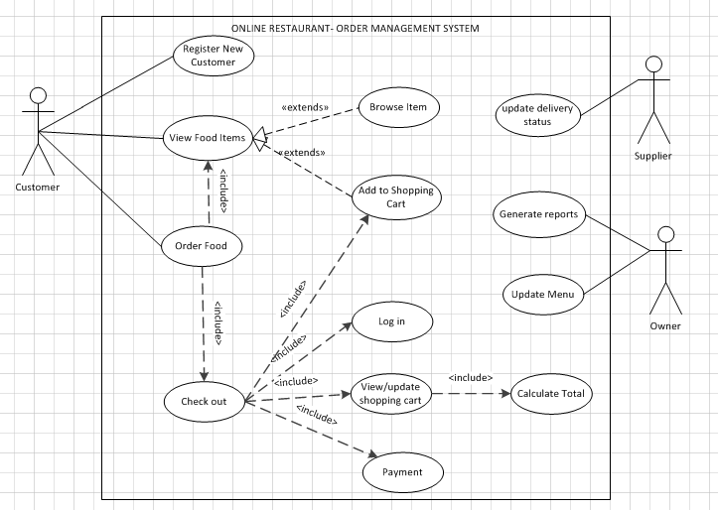

System Use Case Diagram

# System Class Domain Diagram

System Class Domain Diagram

# Project scope

The project is designed in three steps

1. Development

2. Evaluation/Testing

3. Deployment

Development would be carried out in agile methodology in a Scrum development setup. The scrum master would hold weekly meetings to decide the current development progress, obstacles and to assess the deliverables the previous sprints. Pivotal Tracker Project Development Tool would be used by all the developers in the team in order to keep track of each other’s contribution to the project and to maintain effective communication.

For evaluation/Testing, the project would be hosted locally and test with test data input, to make sure that expected system functionalities properly work.

Deployment would be in the client’s existing server (GoDaddy.com).

**This application will consist of the following features:**

Appropriate website with ordering acceptance

Processing and acknowledgement

Feedback

**This includes following main modules:**

Administrator Manages Online Menu

Customer Can Manage his/her Account

Customer Can Order Food

Administrator Manage Order

Customer Make Payment Online

## Administrator Manages Online Menu

**User Story 1;**

Owner manages menu items

**Description**

Owner needs to delete and add menu items into item list in order to ensure any item displayed are valid for service. User can open the site to view the restaurant items.

1. Create template for web solution

2. Create master page, default page, about us page and contact page

3. Owner logs in as the manager with his password (user logins as a role of administrator)

4. Administrator can delete any menu item from database.

5. Manager can add new items to the database.

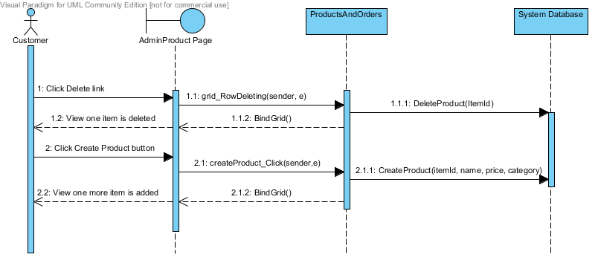

Owner Manage Online Menu – Sequence Diagram

## Customer Can Manage his/her Account

The user interface is designed for new customer to create an account or existing users to log in to their accounts and to navigate through the website for order placement. The data would be saved in a database.

**User Story 2;**

New customer creates an account.

**Description**

User provides user name, password, security question and answer to create a unique account in the website.

1. For password, it must at least be 7 in length and must include at least one special character.

2. User creates security question and answer.

3. All information will save in database.

4. After website accepts entered information and creates an account for the customer, customer can get into the Customer Details page.

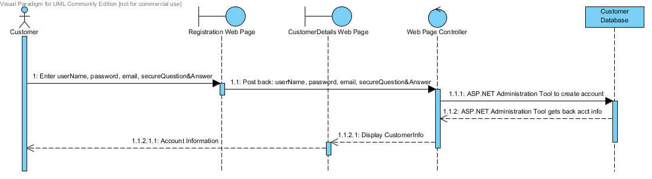

**Customer Registration Sequence Diagram**

**User Story 3;**

Customer update personal information

**Description**

After customer creating a new account, in the Customer Details page, customer can enter and save his first name, last name, living address and phone number in the account.

1. All the entered information must save in the database.

2. After the system accepted the information, information can be retrieved from database and post back to the Customer Details page for customer viewing.

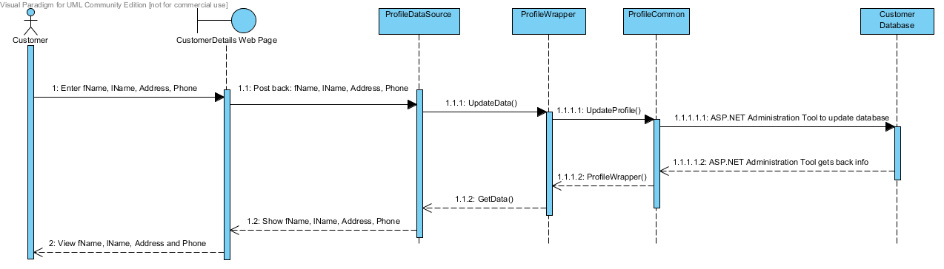

Customer Updates Personal Information Sequence Diagram

**User Story 4;**

Customer saves credit card information in account

**Description**

In customer's account, customer can save his credit card number, cardHolder name, card issueDate, card expiryDate, card issueNumber and cardType in website database.

1. Each piece of the above credit card information must have a field for customer to enter in the editing mode of CustomerDetails page.

2. Credit card information must be encrypted before saving to database.

3. The encrypted credit card information must save in database for each customer.

4. Credit card information must be decrypted after retrieved from database.

5. After saving the credit card information, system only shows the last four digit of the card number and hides the previous digits with xxxx-xxxx-xxxx symbol in the viewing mode.

6. If customer didn't provide credit card information to save, the viewing mode of CustomerDetails page displayed "Not entered." instead of the partial hiding credit card number.

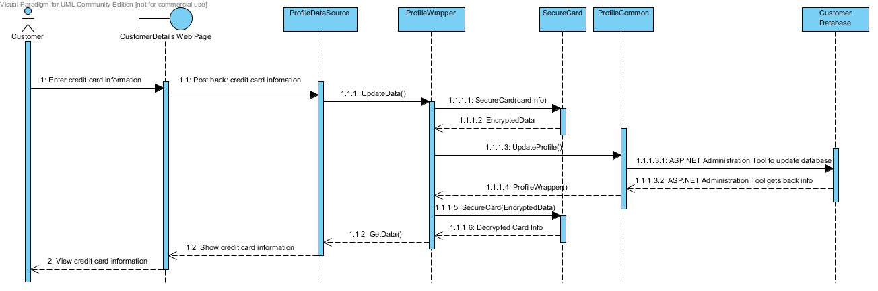

Saving Credit Card Information Sequence Diagram

**User Story 5;**

Customer cancels the account.

**Description**

If customer doesn’t want to hold the account in system, he can cancel his personal account.

1. Inside customer's account, system should provide a Cancel Account button to click when he wants to remove all his information and not own an account anymore.

2. System should pop up a message box to verify from the customer. Make sure customer is not cancelling his account by accidentally clicking the button.

3. All the data and information related to the customer should be deleted from the database.

4. After system deleted all the information of the customer, customer should be redirected to a page which is out of the account.

5. After customer cancelled his account, he cannot use his user name and password to login again. His account will not exist in the system anymore.

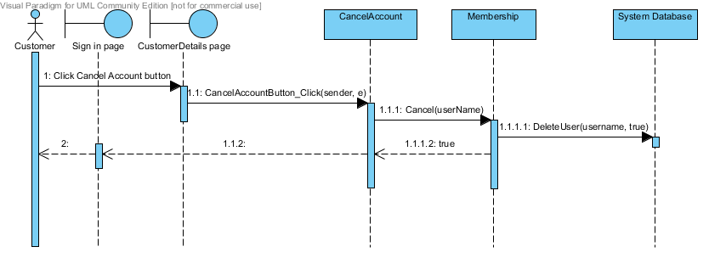

Customer Cancels the Account Sequence Diagram

## Customer Can Order Food

This would display all the menu items under different categories, and option to add items to shopping cart.

Order Food – Use Case Diagram;



Order Food – Use Case Diagram

Order Food – Sequence Diagram;

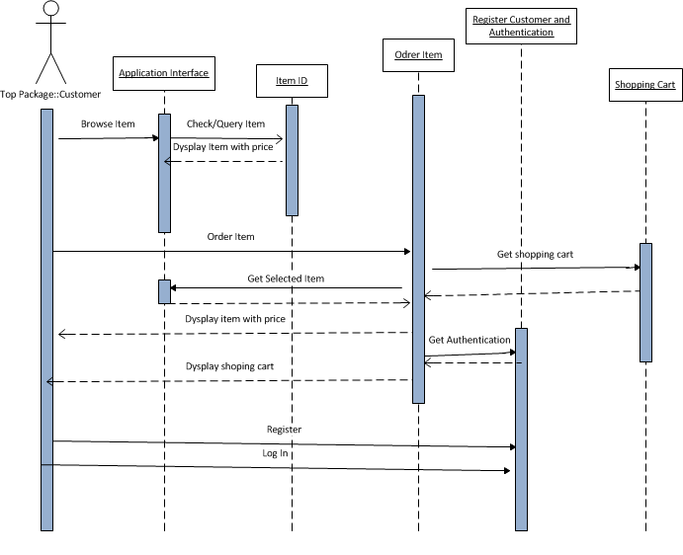

Order Food – Sequence Diagram

**User Story 6;**

Sri Lankan Menu

**Description**

1. This page allows user to select Sri Lankan menu items and add them to cart.

2. User will see all Sri Lakan menu items with select option.

3. Each selected item will be added to cart and the cart is displayed.

4. On cart, user can modify the quantity required.

5. Finally, user can click on Pay button which will direct to payment page.

**User Story 7;**

Tandoori Menu

**Description**

1. This page allows user to select Tandoori menu items and add them to cart.

2. User will see all Tandoori menu items with select option.

3. Each selected item will be added to cart and the cart is displayed.

4. On cart, user can modify the quantity required.

5. Finally, user can click on Pay button which will direct to payment page.

**User Story 8;**

Gujarati Menu

**Description**

1. This page allows user to select Gujarati menu items and add them to cart.

2. User will see all Gujarati menu items with select option.

3. Each selected item will be added to cart and the cart is displayed.

4. On cart, user can modify the quantity required.

5. Finally, user can click on Pay button which will direct to payment page.

**User Story 9;**

User can add items to shopping cart

**Description**

1. Menu items are displayed on screen with select capability.

2. Selected items are added in to shopping cart.

3. Quantity required can be adjusted on shopping cart.

4. Once pay button is clicked on shopping cart, user is offered payment screen.

**User Story 10;**

Modify Shopping Cart

**Description**

1. Customer can go back and forward to add more items.

2. Customer can delete already selected item from the shopping cart.

3. Once pay button is clicked on shopping cart, user is offered payment screen.

**User Story 11; \***

Cancel order

**Description**

Customer, supplier or the owner can cancel an order.

1. Customer can cancel a pending order not delivered and he will be refunded.

2. Supplier can cancel with a valid reason a pending order not delivered and the customer will be refunded

3. Manager can cancel a pending order with a valid reason , and the customer will be refunded.

## Administrator Manage Order

This would allow administrator to assess the delivery status of a placed order.

**User Story 12;**

Administrator can manage orders

**Description**

1. Administrator can enter a number to display the most recent orders list.

2. Administrator can enter a range of dates to display orders between these two days.

3. Administrator can select an order from the order list to view order details.

4. Administrator can edit order by update delivery status, shipping date and comment.

5. Administrator can cancel the edited information.

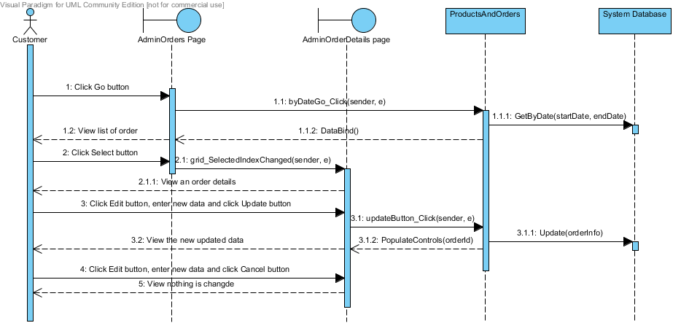

Administrator Manage Order – Sequence Diagram

## Customer Make Payment Online

This would give payment options to customers.

**User Story 14;**

Customer can make payment online

**Description**

Customer will make payment for selected food items added to his shopping.

1. This functionality will be added to a button available on shopping cart page.

2. Once clicked, it checks whether the user is login or not.

3. If user is not login, system will direct the user to login page.

4. If user is an existing customer, user just need to log in, otherwise user need to register an account first.

5. After user login, user can click shopping cart and click the checkout button again.

6. System will direct user to a checkout page. The checkout page shows user’s order information and account information for user to confirm.

7. When user click place order button in the checkout page, shopping cart items are moved to order table in the database, and shopping cart is empty. User will be direct to a Paypal website to pay payment.

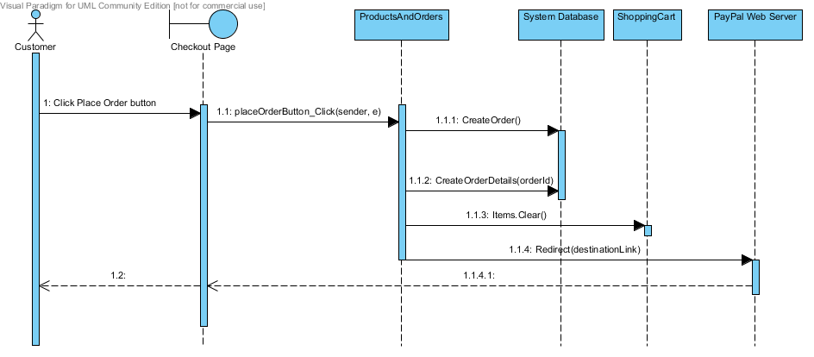

Customer makes payment – Sequence Diagram

# Management Structure

## Project Lifecycle

The functionality is prioritized at project inception and time-boxed releases are delivered, at which point additional functionality is incorporated to the code base. Upon each consecutive release, prior development activities may be revisited as necessary to address priority shift and requirements volatility.

## Project Organization

**External Interfaces**

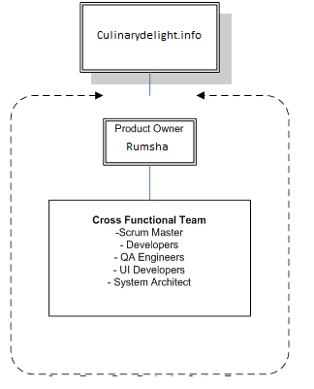

External Interfaces

### Internal Structure

This project can be completed with a team of five people in a period of 15 weeks. The team will consist of software engineers capable of performing various tasks starting from requirements gathering, designing, database management, developing, testing to management. All the members will rotate between different roles to the final product delivered.

Internal Structure

### Roles and Responsibility

|  |  |
| --- | --- |
| **Role** | **Responsibility** |
| Scrum Master | Mitigate project issues that may impede progress as they arise. Due to limited resources, he also will involve in other tasks as necessary. |
| Product Owner | Control the resources allocated to the project. |
| Project Team | Implement the goals and ideas of the project |

### Staffing

The project will be completed with a team of five members within 15 weeks.

The team will include the following members:

1 Scrum Master (Developer)

4 Developers

## Risk Management

### Top Risks List

* New Technologies
* Cost factor
* Time involved during the development.
* Scope creep
* Project management failures with given conditions of schedule and resources.

|  |  |  |
| --- | --- | --- |
| **Risk** | **Probability** | **Impact(0-10)** |
| 1 | 0.10 | 3 |
| 2 | 0.35 | 6 |
| 3 | .30 | 3 |
| 4 | .05 | 5 |
| 5 | .20 | 4 |

### Risk Mitigation Strategy:

* A team member who is familiar with the new technology will educate the other members.
* Search internet and enhance the knowledge.
* Tasks would be assigned based on individual skills of team members.
* Requirements will be revised many times to through each consecutive sprint to ensure that clarity is achieved.
* Throughout every sprint, each decision will be evaluated to make sure that it aligns with the overall goals of the project.
* The team will undergo many team building meetings as deemed necessary by the team.

# Planning and Control

## Estimation Method

The project is scheduled to be carried out throughout 15 weeks. The project presentation is scheduled in the The customer will set the release date. The customer and the development team will then come up with an agree set of functionalities to be delivered on the release date. The customer prioritizes the list of features according to their needs and the development team will provide the estimates for implementing the features.

## Resource Identification

### Staff

The team size will be constant throughout the project.

### Time

Start Date: Sep 03rd 2013   
End Date: December 2nd week 2013

The final released date is set to second week of December 2013. Features are to be delivered iteratively every week.

### Cost

N/A

## Tracking and control

The Scrum Master/Development Team oversees all the Scrum meetings and tracks the development status. The development team identifies the initial backlog at the start of the sprint, and periodically tracks the progress made by the development team. Progress tracking is done during the Scrum meetings, where team members are required to state their development progress relative to the sprint backlog.

To improve the process of identifying the number tasks to complete for a particular sprint and the length of the sprints, metrics that address the questions of “how many tasks should be associated for each sprint?” and “how long should a sprint last for” will be utilize. The selected metrics should assist the Scrum Master/Development Team in writing up sprint backlogs.

## Milestones

### Major Milestones

The final project documentation and presentation is on second week of December 2013.

### Minor Milestones

These would be the weekly deliverables at the end of each week, as outlined in the Deliverables schedule in the Project draft.

## Reporting

### Weekly Report

Team members are required to give a feedback of their weekly progress relative the expected sprint delivery.

### Sprint Report

The Scrum Master is responsible at the beginning of each sprint, to assess the work done during the previous sprint, and present the total outcome to the development team and the product owner. This would help the team and the product owner to evaluate the current status.

## Estimation Refinements

New estimates and time boxing is done according to the outcome of meeting with the team and the product owner.

# Technical Process

## Methods, Tools and Techniques

Scrum Methodology: The whole project is carried out in a number of weekly sprints.

Revision Control: GitHub will be used to track changes to all documents, source code, and any other relevant files.

Daily Builds: Source code will be built every night to avoid integration issues.

## Technology

### Environment

The web-client shall be accessible via http request forwarded through any of the supported browsers listed below:

* Mozilla Firefox 1.07 or higher
* Microsoft Internet Explorer 6.0 or higher
* Netscape Navigator 7.0 or higher

### Methods, Tools and Techniques

Software Tools:

* .NET 2010 Framework
* Pivotal Tracker will be used to track overall progress.
* Microsoft Office 2010
* SQL Server 2000
* IIS Web Server 6.0
* Pivotal Tracker Tracking System

# Hardware requirements;

### Minimum Hardware requirements for Online Restaurant-Ordering System web hosting:

Online Restaurant-Ordering System is an online application to allow users ordering food through internet. Therefore, this application must be hosted on a web server. Since the application will be written in ASP.Net (using C#) and will connect to a database, we prepared the following minimum hardware requirements to successfully host this web application.

### Hardware minimum requirements for installing web server and SQL server

* 166 MHz or faster Pentium-compatible CPU: 133 MHz is required for Windows Server 2003 (Microsoft Corporation [MC], 2003); However 166 MHz is minimum requirement for SQL Server (Northpointe Institute [NI], 2009).
* 256 MB of RAM or higher: 128 MB is minimum requirement for Windows Server 2003 (MC, 2003), and 128 MB or more is recommended for SQL Server (NI, 2009).
* 2.5 GB hard disk or higher: 1.5 GB is minimum requirement for Windows Server 2003 (MC, 2003), and 1 GB is good for SQL Server (NI, 2009).
* 4 CPUs on one machine (MC, 2003).
* Super Video Graphics Adapter (SVGA) or higher monitor: 800 x 600 or higher resolution required for the SQL Server (NI, 2009)
* Microsoft Mouse or compatible pointing device (NI, 2009)

## Project Artifacts

|  |  |
| --- | --- |
| **Document Name** | **Description** |
| Letter of Engagement | A general overview of the project with some of its key features. |
| Project Plan | A document containing the following subsections:   * Project Scope * Management Structure * Planning and Control * Software and Hardware requirements |
| Project package | Source code required to build an executable product and incorporate the solution with deployment tools on the client- and server-side platforms. |
| User Manual | Formal User manual will be provided to help users to use the system. |
| Development Documentation | Project plan of action documenting all the resources used including diagrams, description and Team Member activities and involvement. |
| Administrator Guide | This document describes all the steps in installing and how to use the website effectively. |